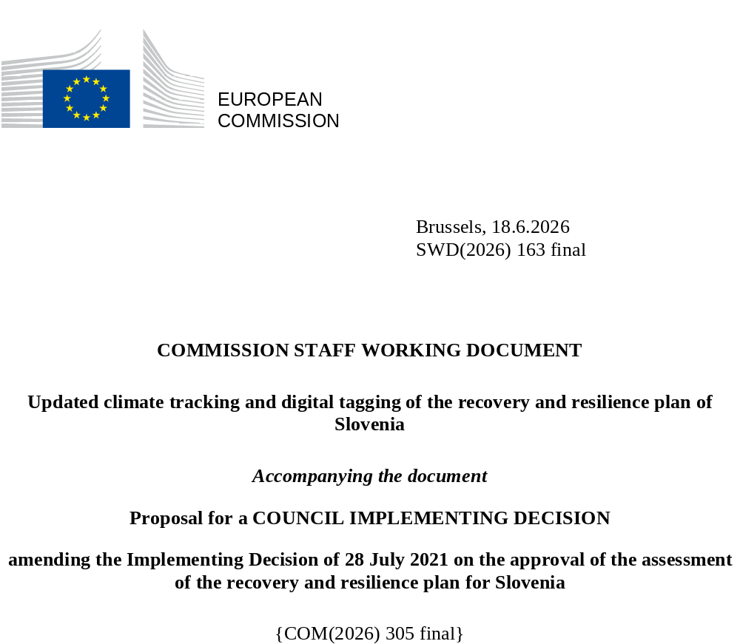

Updated climate tracking and digital tagging of the recovery and resilience plan of Slovenia
The table below presents the detailed application of the climate tracking and digital tagging methodologies set out respectively in Annexes VI and VII to Regulation (EU) 2021/241 in the modified Slovenian recovery and resilience plan.

Int. Field = intervention field.
Coeff. = Coefficient for the calculation of support to climate change objectives and to digital transition, on the basis of Annex VI and Annex VII of the RRF Regulation.
New or revised measures are marked in yellow to distinguish them from the unchanged measures in the RRP.

Measure  ID | Measure/  Sub-Measure Name | Budget  (EUR m) | Climate |  | Digital
Measure  ID | Measure/  Sub-Measure Name | Budget  (EUR m) | Int. field | Coeff. % | Int.  field | Coeff. %
C1K1.I.D | Energy efficient restructuring of district systems with the use of renewable sources | 2,9 | 034bis0 | 100%
C1K1.I.E.L | Production of electricity from renewable energy sources | 40,26 | 032 | 100%
C1K1.I.F | Strengthening the electricity distribution network (low-voltage network) | 40,00 | 033 | 100% | 033 | 40%
C1K2.I.B.a | Sustainable renovation of buildings | 43,62 | 026bis | 100%
C1K2.I.B.c | Sustainable renovation of buildings - individual upgrading of technical building systems | 10,00 | 026 | 40%
C1K2.I.B.L.a | Continuation of sustainable renovation of buildings (loans) | 14,45 | 026bis | 100%
C1K2.I.B.L.c | Continuation of sustainable renovation of buildings - individual upgrading of technical building systems (loans) | 3,05 | 026 | 40%
C1K3.I.E.a | Social and economic resilience to climate-related disasters in the Republic of Slovenia – SLO SERCID - Construction of new energy efficient buildings | 1,79 | 025ter | 40%
C1K3.I.E.c | Social and economic resilience to climate-related disasters in the Republic of Slovenia – SLO SERCID - Trainings and awareness raising measures: fires | 0,07 | 036 | 100%
C1K3.I.F.a | Climate change adaptation - Reducing flood risks | 47,36 | 035 | 100%
C1K3.I.F.a | Climate change adaptation - Reducing flood risks | 3,45 |  |  | 055 | 100%
C1K3.I.F.L.a | Climate change adaptation - Reducing flood risks (loans) | 67,40 | 035 | 100%
C1K3.I.F.L.b | Climate change adaptation - Reducing flood risks (loans) | 22,88 | 037 | 100%
C1K3.I.G | Centre for Seeds, nurseries and forest protection | 5,10 | 025ter | 40%
C1K3.I.H | Urban waste water discharge and treatment projects | 34,00 | 041bis | 40%
C1K3.I.H.L | Urban wastewater discharge and treatment projects (loans) | 14,65 | 041bis | 40%
C1K3.I.I | Drinking water projects | 6,70 | 039bis | 40%
C1K3.I.I.L | Drinking water projects (loans) | 16,08 | 039bis | 40%
C1K4.I.C.a | Increasing railway infrastructure capacity_ Upgrading of the railway line Kranj-Jesenice-d.m. | 13,10 | 065 | 100%
C1K4.I.C.c | Increasing railway infrastructure capacity - upgrading of Grosuplje and Domžale railway stations | 10,41 | 066 | 40%
C1K4.I.C.d | Increasing railway infrastructure capacity - Upgrading of the Ljubljana-Brezovica – Preserje – Borovnica railway line | 192,79 | 064 | 100%
C1K4.I.D.b | Digitalisation of road infrastructure - road dedicated in part to GHG emissions reduction | 12,52 | 063bis | 40% | 063bis | 100%
C1K4.I.E | Fostering the deployment of alternative fuels infrastructure in transport | 7,04 | 077 | 100%
C1K4.I.C.L.a | Further increasing railway infrastructure capacity - Upgrading the Ljubljana railway station (phase A Dunajska overpass) (loans) | 33,31 | 064 | 100%
C1K4.I.C. L.b | Further increasing railway infrastructure capacity – Upgrading the Nova Gorica railway station (loans) | 43,00 | 065 | 100%
C1K5.I.B.a | Integrated strategic project for the decarbonisation of Slovenia through the transition to a circular economy_Contributing to green skills | 5,12 | 01 | 100%
C1K5.I.B.b | Integrated strategic project for the decarbonisation of Slovenia through the transition to a circular economy_Support to environmentally-friendly production processes and resource efficiency in SMEs | 9,90 | 047 | 40%
C1K5.I.C | Increased wood processing to accelerate the transition to a climate-neutral society | 25,02 | 047 | 40%
C2K1.I.B.a | Industrial/business digital transformation programme_large enterprises | 33,81 |  |  | 010bis | 100%
C2K1.I.B.b | Industrial/business digital transformation programme_SMEs | 10,00 |  |  | 010 | 100%
C2K1.I.D | Cross border and multi-country projects - European common data infrastructure and services | 5,00 |  |  | 021quater | 100%
C2K1.I.E | Cross border and multi-country projects - Low-Power Processors and Semiconductor Chips | 1,50 |  |  | 021quater | 100%
C2K2.I.G.a | Modernising the digital environment of public administration | 52,23 |  |  | 011 | 100%
C2K2.I.G.c | Modernising the digital environment of public administration - Support the national quantum communication infrastructure | 2,00 |  |  | 021quater | 100%
C2K2.I.H | Gigabit infrastructure | 24,86 |  |  | 053 | 100%
C2K2.I.I | Digitalisation of internal security | 23,63 |  |  | 011 | 100%
C2K2.I.J | Digitalisation of education and science | 63,78 |  |  | 055 | 100%
C2K2.I.K | Green Slovenian location framework | 33,50 |  |  | 011 | 100%
C2K2.I.L | Digitalisation in the field of agriculture, or food , or forestry | 24,06 |  |  | 011 | 100%
C2K2.I.M | Digitalisation in the field of culture | 8,56 |  |  | 011 | 100%
C2K2.I.N | Digitalisation in the field of justice | 9,84 |  |  | 011quater | 100%
C2K2.I.O | Voluntary contribution to the EuroHPC Joint Undertaking for AI Gigafactories or equivalent AI infrastructure | 50,22 |  |  | 021quater | 100%
C2K2.I.O.L | Further voluntary contribution to the EuroHPC Joint Undertaking for AI Gigafactories or equivalent AI infrastructure | 21,59 |  |  | 021quater | 100%
C3K1.I.B.a | Financing of research and innovation projects in the field of green or digital transition - focusing on the low carbon economy, resilience and adaptation to climate change | 7,50 | 022 | 100%
C3K1.I.B.b | Financing of research innovation projects in the field of green and digital transition - digital related R & I | 7,50 |  |  | 009bis | 100%
C3K1.I.B.c | Financing of research innovation projects in the field of green and digital transition - focusing on circular economy | 36,64 | 023 | 40%
C3K1.I.D | RDI demonstration or pilot projects in the field of the green transition | 21,00 | 023 | 40%
C3K2.I.C.a | Providing innovative ecosystems of economic and business infrastructure: SMEs | 83,00 | 047 | 40%
C3K2.I.C.b | Providing innovative ecosystems of economic and business infrastructure: large enterprises | 38,00 | 047bis | 40%
C3K4.R.A | Strenghtening the sustainable development of tourism - upgraded data monitoring in the Slovenian Green Tourism Scheme | 1,00 |  |  | 011 | 100%
C3K4.I.B.a | Sustainable development of Slovenia’s tourist accommodation offer to raise the added value of tourism - energy renovation | 5,58 | 025 | 40%
C3K4.I.B.c | Sustainable development of Slovenia’s tourist accommodation offer to raise the added value of tourism - new energy efficient buildings | 14,32 | 025ter | 40%
C3K5.R.A.a | Renovating the education system for the green and digital transitions - green skills | 1,31 | 01 | 100%
C3K5.R.A.b | Renovating the education system for the green and digital transitions - digital skills | 1,31 |  |  | 108 | 100%
C3K5.R.B.a | Reform of higher education for a green and resilient transition - green skills | 0,85 | 01 | 100%
C3K5.R.B.b | Reform of higher education for a green and resilient transition - digital skills | 0,85 |  |  | 108 | 100%
C3K5.R.C.a | Revision of vocational education and training programmes (VET) - green skills | 1,67 | 01 | 100%
C3K5.R.C.b | Revision of vocational education and training programmes (VET) - digital skills | 1,67 |  |  | 108 | 100%
C3K5.I.E.a | The comprehensive transformation of green and digital education - digital skills | 18,45 |  |  | 108 | 100%
C3K5.I.E.b | The comprehensive transformation of green and digital education - green skills | 1,44 | 01 | 100%
C3K5.I.F.a | Pilot projects for higher education reform for a green and resilient transition - green skills | 28,49 | 01 | 100%
C3K5.I.F.b | Pilot projects for higher education reform for a green and resilient transition - digital skills | 28,49 |  |  | 108 | 100%
C3K5.I.H.b | Greening education infrastructure in Slovenia | 37,95 | 025ter | 40%
C3K5.I.H.d | Greening education infrastructure in Slovenia | 1,90 | 025 | 40%
C3K5.I.H.L.a | Further greening education infrastructure in Slovenia (loans) | 22,77 | 025ter | 40%
C3K5.I.H.L.d | Further greening education infrastructure in Slovenia (loans) | 14,49 | 025 | 40%
C4K1.I.C | Health digital transformation | 76,60 |  |  | 095 | 100%
C5K17.I.C | Strengthening the electricity distribution network (medium-voltage network) | 47,43 | 033 | 100% | 033 | 40%
C5K17.I.D | Energy efficiency and decarbonisation of the economy – SMEs | 16,91 | 024 | 40%
C5K17.I.E.a | Promoting alternative fuels infrastructure in transport – rolling stock | 3,00 | 074 | 100%
C5K17.I.E.b | Promoting alternative fuels infrastructure in transport – alternative fuels infrastructure | 10,80 | 077 | 100%
C5K17.I.E.c | Promoting alternative fuels infrastructure in transport – rolling stock | 44,03 | 074 | 100%

